CSA 1717-ARTIFICIAL INTELLIGENCE
LAB EXPERIMENTS
Abinaya Sri J(192524429)
AIM
To implement the Depth-First Search (DFS) algorithm in Python to traverse a graph.
OBJECTIVE
To traverse all the nodes of a graph using the Depth-First Search (DFS) algorithm. To understand the concept of stack (recursion) and graph traversal in Artificial Intelligence.
ALGORITHM
Step 1: Start.
Step 2: Create the graph using an adjacency list.
Step 3: Create an empty list called visited to store the visited nodes.
Step 4: Select the starting node.
Step 5: Mark the starting node as visited and print it.
Step 6: Visit each adjacent node of the current node.
Step 7: If an adjacent node has not been visited, recursively call the DFS function for that node.
Step 8: Repeat Steps 5–7 until all reachable nodes have been visited.
Step 9: Stop.
SOURCE CODE
# Graph represented as an adjacency list
graph = {
'A': ['B', 'C'],
'B': ['D', 'E'],
'C': ['F'],
'D': [],
'E': ['F'],
'F': []
}
# List to store visited nodes
visited = []
# DFS Function
def dfs(node):
if node not in visited:
print(node, end=" ")
visited.append(node)
for neighbour in graph[node]:
dfs(neighbour)
# Driver Code
print("DFS Traversal:")
dfs('A')

FLOW CHART
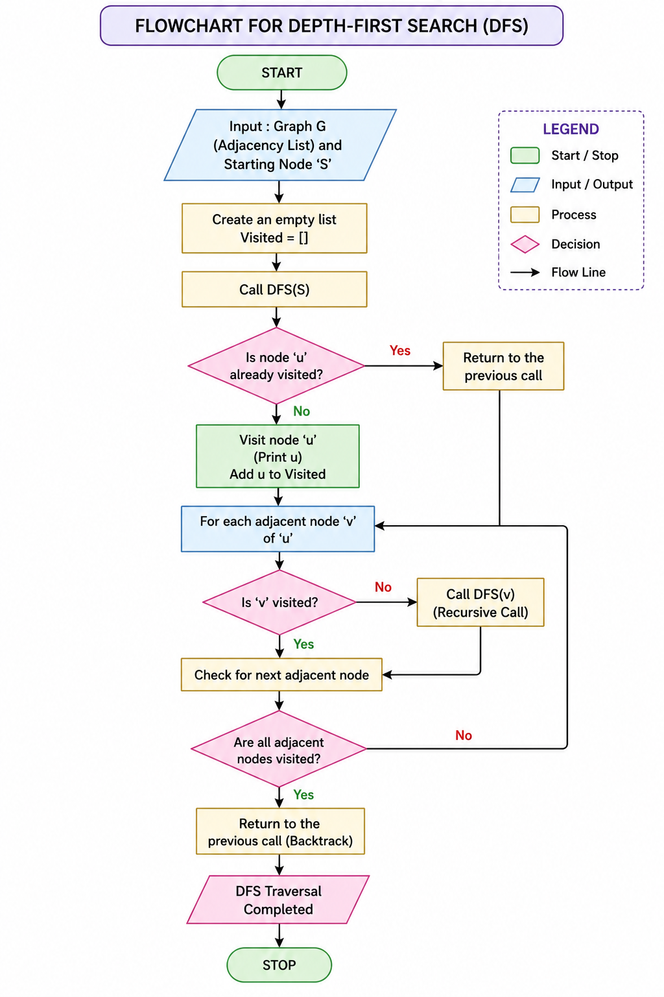
OUTPUT
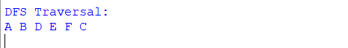
RESULT
The graph was successfully traversed using the Depth-First Search (DFS) algorithm.

